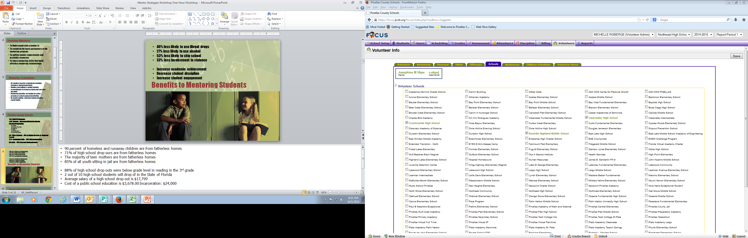

Welcome to the Mentor Recruitment Fair Program



Please sign-in at the registration table for the mentor workshop of your choice.

Large Conference Room

Mentor Workshops

12:00 to 1:00p.m. – 1:30 to 2:30p.m. – 4:00 to 5:00p.m. – 5:30 to 6:30p.m.

Grand Ballroom

Please select a school and the grade level to be matched with a student

Schools are arranged in the ballroom by

North County – Mid-County – South County

Small Conference Room

Volunteer Registration, Background Screening (Level1) Level 2 Screening ($45.00 fee)

*Level 2 is only needed if you are supervising students such as: fieldtrip driver*

Office of Strategic Partnerships, Family & Community Relations

Dr. Valerie Brimm, Director

Michelle Roberge, District Volunteer Coordinator

727-588-5050

*Thank you to our sponsors*



Bright House 